**COVID-19 Modelling – Comparison of “Hidden” and “non-Visible” Infected Compartments**

**Methodology**

Two SIR-based deterministic compartmental models were adapted to compare the epidemic curves obtained under two scenarios/model structures:

* The presence of a “visible” and “non-visible” infectious infected compartment (SIVR Model).
* The presence of a “hidden” and “non-hidden” infected compartment, with the “hidden” being non-infectious (SIHR Model).

**SIHR Model**

$$\frac{dS}{dt}=-β_{1}SI-β_{2}SI$$

$$\frac{dI}{dt}=β_{1}SI-µI$$

$$\frac{dH}{dt}=β_{2}SI-µH$$

$$\frac{dR}{dt}=µI+µH$$

The SIHR model follows a generic SIR model structure, with the addition of a hidden (H) compartment to represent the possibility for SARS-COV 2 infection to result in a non-infectious asymptomatic state, which progresses to a recovered state at a rate equal to the reciprocal of the duration of infectiousness (µ). An additional transmission parameter was also introduced into this model (β2), to describe the possibility for an enhanced infectious transmission rate that results in “hidden” infections (relative to those which cause “normal” infection – β1). Infections in this “hidden” compartment are driven solely by those who are in a “non-hidden” infectious disease state.

**Table 1 – Parameter descriptions for the SIHR model**

|  |  |
| --- | --- |
| Parameter | Description |
| β1 | Per capita rate of transmission that result in “non-hidden” infections. |
| β2 | Per capita rate of transmission that result in “hidden” infections. |
| µ | Per capita rate of disease recovery, or the reciprocal of the average duration of infectiousness or the reciprocal of the generation time (in the absence of a latency period) |

**SIVR Model**

$$\frac{dS}{dt}=-βS\left(I_{v}+I_{nv}\right)$$

$$\frac{dI_{v}}{dt}=βSv\left(I_{v}+I_{nv}\right)-µI_{v}$$

$$\frac{dI_{nv}}{dt}=βS(1-v)\left(I_{v}+I_{nv}\right)-µI_{nv}$$

$$\frac{dR}{dt}=µI_{v}+µI_{nv}$$

The SIVR model follows a SIR model structure, with two nuances, the separation of the infected (I) compartment into a “visible” (Iv) and “non-visible” (Inv) infected compartments. This describes the possibility that there is a fraction of individuals who become asymptomatically infected (1-v), but remain infectious, therefore being undetected by disease surveillance systems.

**Table 2 – Parameter descriptions for the SIVR model**

|  |  |
| --- | --- |
| Parameter | Description |
| β | Per capita rate of transmission. |
| v | Fraction of individuals who become visibly (symptomatically) infected following SARS-COV 2 infection. |
| µ | Per capita rate of disease recovery, or the reciprocal of the average duration of infectiousness or the reciprocal of the generation time (in the absence of a latency period) |

**Scenario Analysis**

Both models were initiated with the same initial conditions, with S = 0.9999, I/Iv = 0.0001 and with all other SIVR/SIHR compartments being initialised at 0. The SIHR model was run with a specific parameter set to obtain an epidemic curve for the “non-hidden” infected fraction over the projected course of the outbreak. This used epidemiological information on the doubling time (T2) and a basic reproduction number (R0) to obtain relevant β1 and µ rates (eqn 1.1-2). β2 was considered 5-fold larger than β1 as part of a scenario analysis, essentially resulting in five times as many individuals becoming “hidden” relative to “non-hidden” infecteds.

$$R_{0}=β\frac{1}{µ}$$

eqn 1.1

$$\frac{1}{µ}=T_{2}\frac{\left(R_{0}-1\right)}{ln⁡(2)}$$

eqn 1.2

The timing of the epidemic peak and the number of “non-hidden” infected cases at the SIHR epidemic peak was chosen as summary statistics for an approximate Bayesian computation (ABC) model fitting approach. By allowing β, µ and v parameters to vary in the SIVR model, the SIVR epidemic curve was fitted to the outcome measures obtained from the initialised SIHR model. This allowed for the determination of SIVR model parameters that would “match” the epidemic curve produced by the SIHR model. Uniform prior distributions were chosen for the β, µ and v model parameters ($U\left(0,1\right)$) for the model fitting process (Figure 1).

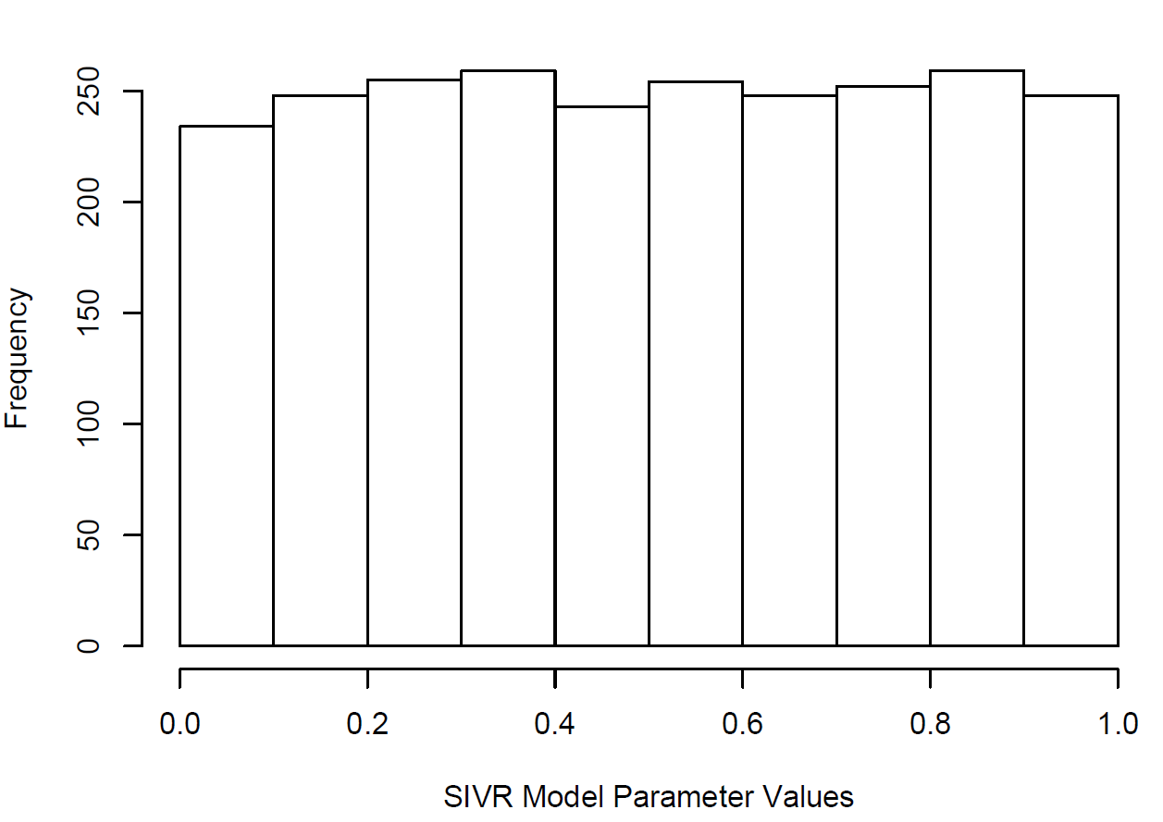

**Figure 1 – Uniform prior distribution used for β, µ and *v* parameters in the ABC model fitting approach.** Ran for 2500 random samples.

The ABC approach was run until the threshold of 2500 accepted particles was reached. The maximum a posteriori (MAP) of the following parameter posterior distributions were used to obtain the parameter values that result in a “matching” epidemic curve for the SIVR model.

**Results**

Using a doubling time of 6 days, a basic reproduction number of 2, and a β2/β1 ratio of 5, the SIHR model was initialised with the following parameters (eqn 1.1-2): β1 = 0.231, β2 = 1.155 and µ = 0.116. The resulting simulation produced an epidemic curve for the “non-hidden” infections in the SIHR model, with an epidemic peak after 63 days and a peak fraction of “non-hidden” infected individuals of 0.026 (Figure 2).

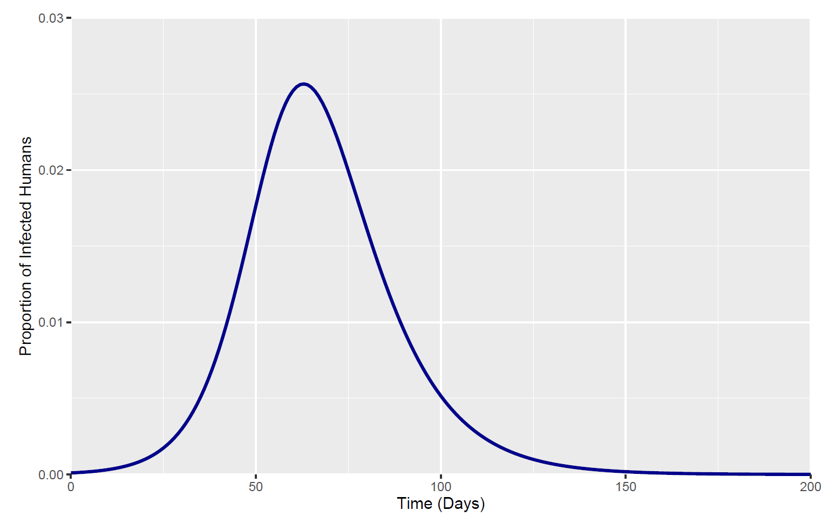

**Figure 2 – Epidemic curve for the fraction of “non-hidden” in the SIHR model.** Initialised with β1 = 0.231, β2 = 1.155 and µ = 0.116. Initialised with S = 0.9999, I = 0.0001, H = 0 and R = 0. The simulation was run for a total of 200 days with a 1 day time step.

The epidemic peak and a peak fraction of “non-hidden” infected individuals of the SIHR model was used as two outcome measures (63 days and 0.026). A summary statistic tolerance of 5% was allowed to enable a greater range of SIVR parameter values to be fit to the desired SIHR epidemic curve and to expedite the model fitting process. The maximum a posteriori (MAP) of these posterior distributions were: β = 0.488, µ = 0.376 and v = 0.13.

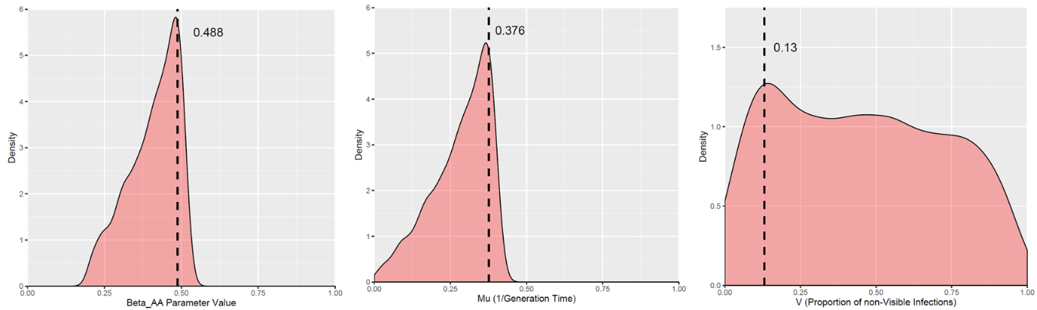

**Figure 3 – Posterior Distribution of β, µ and v SIVR model parameters.** Prior distributions were set for all 3 parameters as $U\left(0,1\right)$. The ABC model fitting approach was run until 2500 particles were accepted.

The MAP of the posterior distributions for β, µ and v parameters resulted in a basic reproduction number of 1.298 in the SIVR model (eqn 1.1). The resulting SIVR epidemic curve (the *v* parameter was slightly altered from 0.13 to 0.094 to provide a closer fit to the SIHR epidemic curve) was plotted against the initialised SIHR epidemic curve (Figure 4).

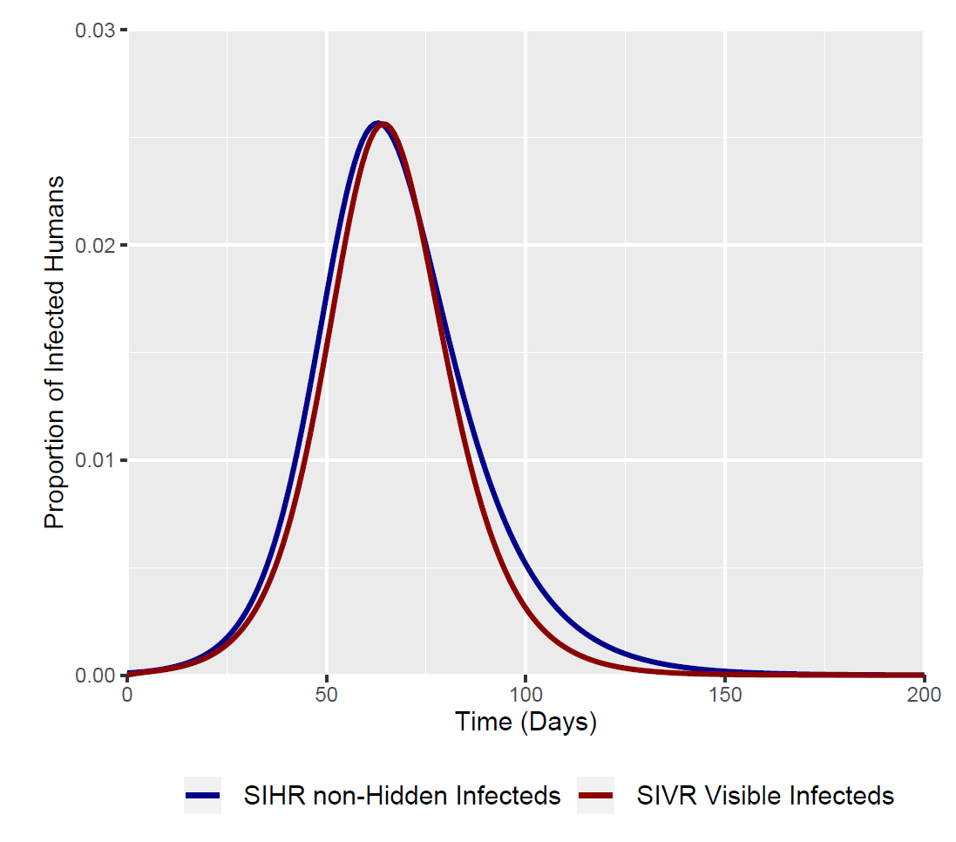

**Figure 4 – Epidemic Curves for the initial SIHR model and the fitted SIVR model.** Both models were run for 200 days with a time step of 1 day. Both models were initiated with S = 0.9999, I/Iv = 0.0001 and all other SIVR/SIHR compartments being initialised at 0.

**Table 1 – Parameter Values for the Plotted Curves**

|  |  |  |
| --- | --- | --- |
| Parameter | SIHR Model | SIVR Model |
| R0 | 2 | 1.298 |
| β1 | 0.231 | 0.488 |
| β2 | 1.155 |  |
| µ | 0.116 | 0.376 |
| v |  | 0.094* |

*Value slightly altered from the obtained MAP